Cambridge Dream

I won't mark the time in detail during my time in the UK, because I did too much every day and forgot which day it happened.

I clearly remember that the mayor of Cambridge came to the college to share with us what the UK is and what kind of city Cambridge is, but it was a pity that I didn't record it because I didn't take pictures. After that, Ms. Laura, the principal of Cambridge Dream, held a mobilization meeting to familiarize us with the student mentors and classmates.

Then we were divided into four groups, namely STEM, AI, ECO, and MEDICINE. I originally chose to go to STEM, but somehow I was assigned to the AI ​​group. However, through so many days of study, I unknowingly developed some interest in artificial intelligence, and I also tried to write some different codes myself, using modules such as decision trees to process data. I learned computer knowledge that I couldn't learn in school, and also learned a lot of software that has never appeared in China, such as the music listening software spodify, which cannot be found in China.

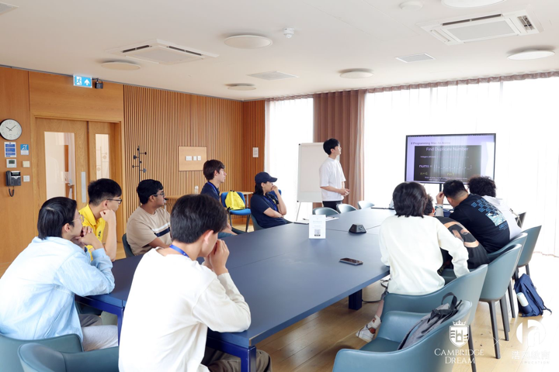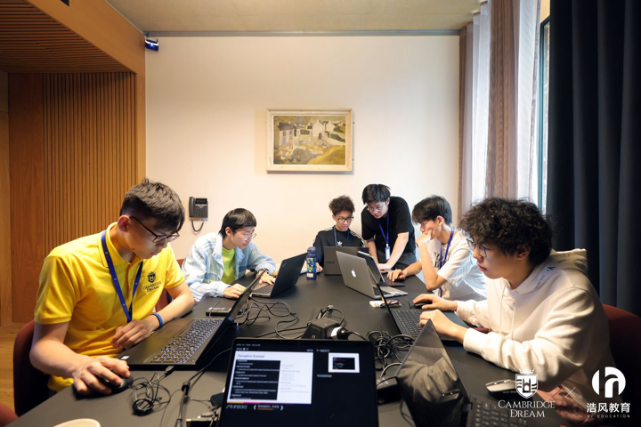

It's not just tutoring, there are also lectures from different fields, such as a workshop on climate adaptation community interaction by Dr Rachel Thorley, fellow of Churchill college. There are lectures on deep sea knowledge by Dr Helen Scoles, etc.

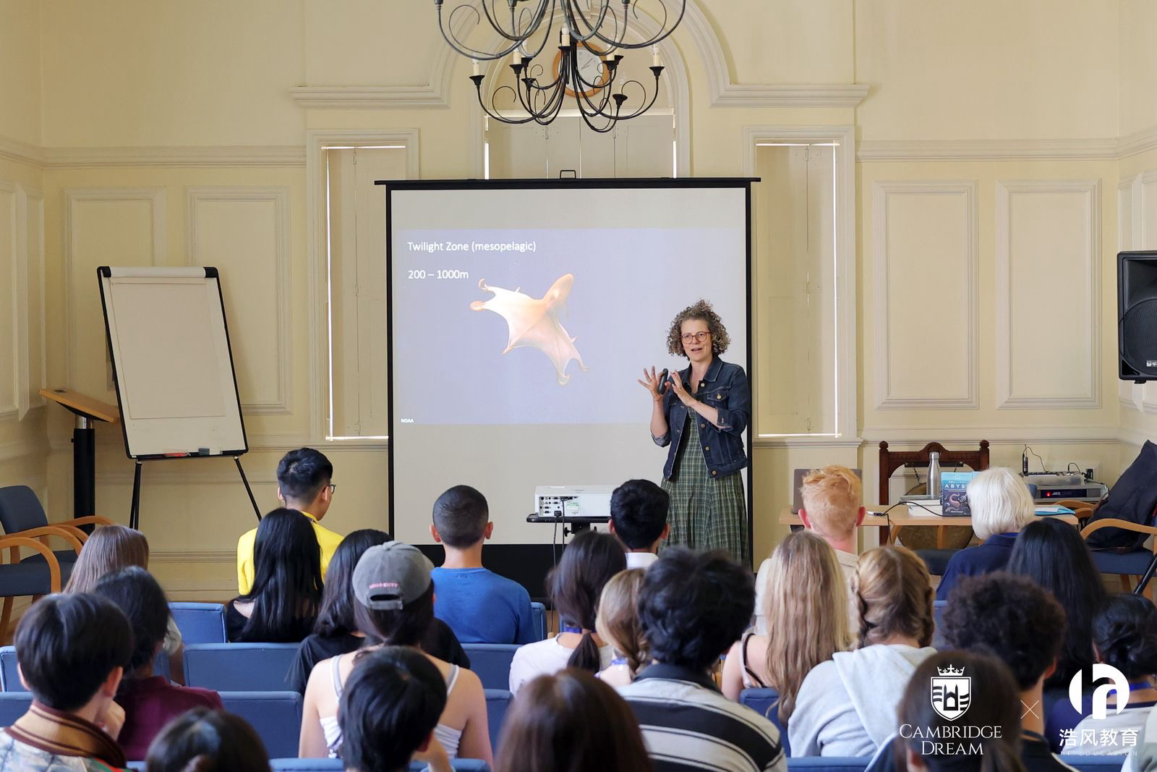

We visited the British Museum and were deeply attracted by the objects on display there. The London Eye, Big Ben and other iconic buildings. I have to say that I really like the lifestyle of the British people. Weekends should not be spent working overtime or staying at home playing games. Sitting on the lawn and chatting with family or friends is also a good lifestyle. What's funny is that my mentor Josh lay down when he heard that I liked the lawn very much.

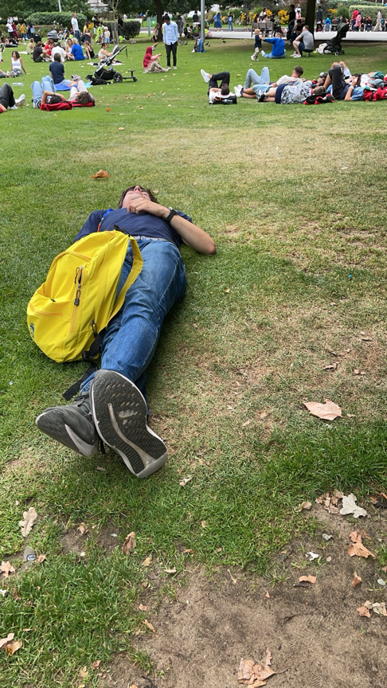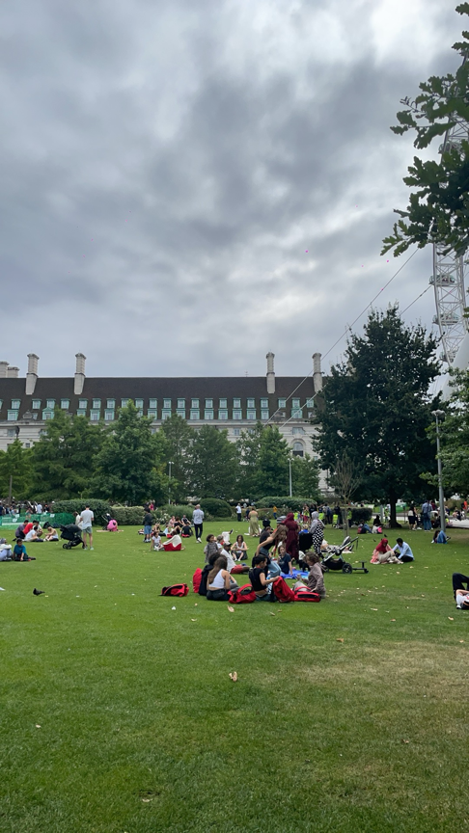

We also felt the enthusiasm of the British people, the local characteristics and some historical sites.

Whether it was the wonderful speech by anthropologist Professor McFarland, the unique British social etiquette, role-playing, the unique Ceilidh dance in the UK, or the Midsummer Night's Dream performed in the outdoor park, I loved them all.

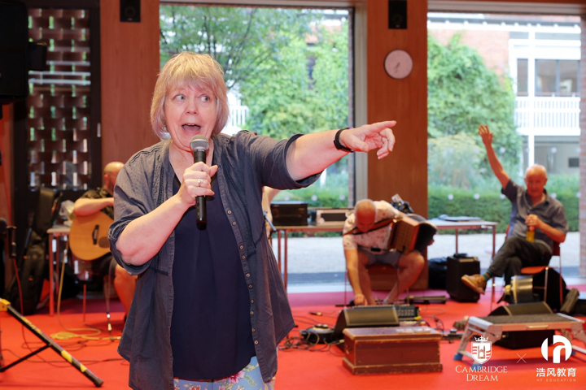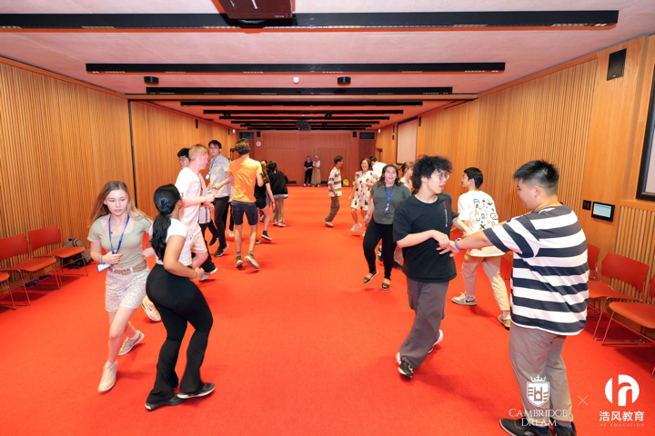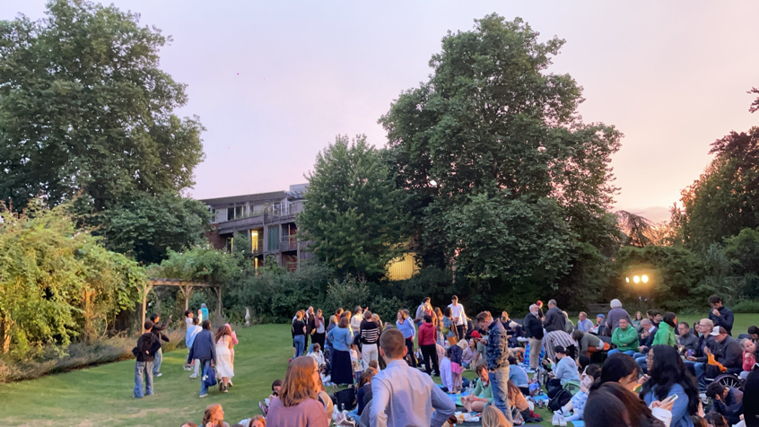

What impressed me the most was the British "food".

It may be because we mostly ate in the cafeteria, but it did not affect my perception of British food. In my opinion, breakfast is the most delicious. Although it is the same every day, I will drink different teas to match this single food. Lunch and dinner are slightly inferior to breakfast. The food is fresh but tasteless. I hope the chef can add more salt, and cakes and other desserts can put less sugar, thank you

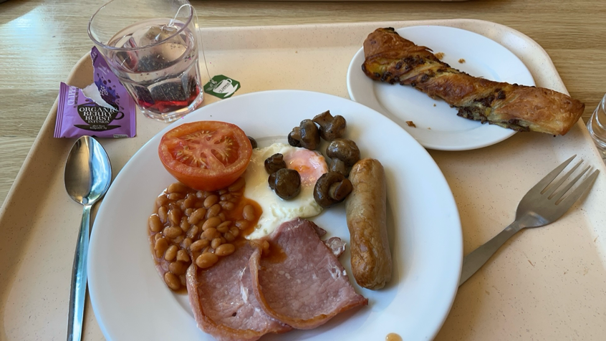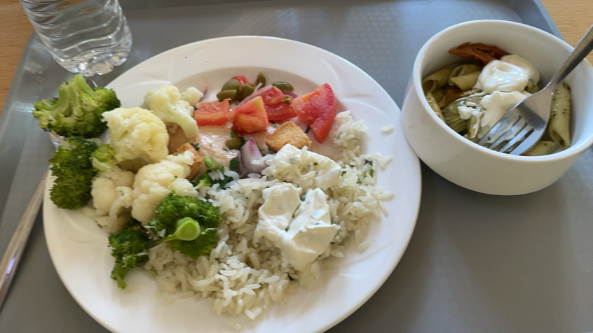

There are many more that I won’t list one by one.

To sum up, I met a lot of new friends during this period, which indirectly improved my English ability, allowing me to communicate with them without obstacles. In addition, I felt the local culture, which laid a foundation for my long-term study in the UK. I learned a lot, not only knowledge, but also skills and abilities in dealing with people. To be honest, this trip to the UK was very helpful to me.